Why Do People Get So Anxious About Math?
By: Orly Rubinsten
https://tinyurl.com/mathanxiety141
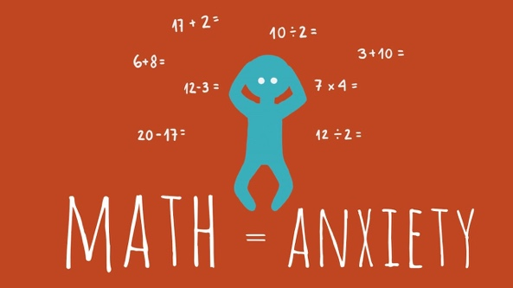
- Researchers think about ___________ % of the population suffers from math anxiety. (1 p)
- Math anxiety ________________ the resources of working memory. (1 point)
  - Increases
  - Decreases
  - Does not affect
  - Improves
- Math anxiety may be the result of: (1 point)
  - The environment (i.e. parents, teachers, friends, society, etc.)
  - Working hard on mathematical problems
  - Learning about the creative and beautiful aspects of mathematics
  - Relaxation techniques
- Since math anxiety is _________ and is frequently associated with _________ skills, it is vital to understand what it is. (1 point)
  - Rare; good
  - Uncommon in schools; excellent
  - Widespread; poor
  - Not ignored; good
- Math anxiety may hinder mathematical achievements since: (1 point)
  - It involves feelings of tension that interfere with the solving of mathematical problems
  - It may lead to avoidance from mathematical tasks
  - It includes low self confidence in one’s ability to learn math
  - All of the above
- Is math anxiety a different name for “being bad at math”? (1 point)
  - Not necessarily: A person could perform better at math if he or she didn’t suffer from math anxiety
  - Yes: Low math ability always results in math anxiety
  - Yes: The proof for this is that professional mathematicians never suffer from math anxiety
  - No: Math anxiety is not related to math performance
- Research in psychology, neurosciences, and education has revealed techniques that can reduce math anxiety. Name 3 different techniques that might help in reducing math anxiety and explain how they can improve math performance. (3 points)

- How does math anxiety affect working memory, and why do such changes in working memory interfere with math performance? (2 points)

